EXPERIMENT – 9

REG – 16BIT0453
NAME – KRISHNA KUMAR MAHTO

Code:

#include<stdio.h>
#include<stdio_ext.h>
#include<stdlib.h>
#define MAX 10

void print_frames(int frames[],int fr)
{
int i;
for(i=0;i<fr;i++)
printf("%d\t",frames[i]);
puts("\n");
}

void fifo(int pages[],int n, int fr)
{
int frames[MAX] = {0};
int i,j,present=0,fr_index=0;

for(i=0;i<n;i++)
{
present = 0;
for(j=0;j<fr;j++)
{
if(frames[j]==pages[i])
{
present = 1;
puts("Page hit");
break;
}
}

if(present == 0)
{
puts("Page miss");
frames[fr_index++ % fr] = pages[i];
}
print_frames(frames,fr);

}
}

void lru(int pages[],int n,int fr)
{
int frames[MAX] = {0}, min, present=0, i, j, k, k_min = 0, new_start;

for(k=0,i=0;k<fr;k++,i++)
{
frames[k] = pages[i];
puts("Page miss");
print_frames(frames,fr);
}

//remain_page = n-fr;

new_start = k;

for(i=new_start;i<n;i++)
{
min = MAX; //for each page[i] reset min (holds the page index of lr element)
present = 0;
for(k=0;k<fr;k++)
{
if(pages[i]==frames[k])
{
present = 1;
puts("Page hit");
break;
}
}

if(present == 0)
{
puts("Page miss");
for(k=0;k<fr;k++)
{
for(j=i-1;j>=0;j--)
{
if(frames[k] == pages[j])
{
if(j<=min)
{
min = j;
k_min = k;
}
break;
}
}
}
frames[k_min] = pages[i];
print_frames(frames,fr);

}
else
print_frames(frames,fr);
}
}

void opt(int pages[],int n, int fr)
{
int frames[MAX] = {0}, max=0, present=0, i, j, k, k_max = 0, new_start, unused_in_future;

for(k=0,i=0;k<fr;k++,i++)
{
frames[k] = pages[i];
puts("Page miss");
print_frames(frames,fr);
}

//remain_page = n-fr;

new_start = k;

for(i=new_start;i<n;i++)
{
max = 0; //for each page[i] reset min (holds the page index of lr element)
present = 0;
for(k=0;k<fr;k++)
{
if(pages[i]==frames[k])
{
present = 1;
puts("Page hit");
break;
}
}

if(present == 0)
{
puts("Page miss");
for(k=0;k<fr;k++) // for each frame..
{
unused_in_future = 1; //for frame (to check if unused in future)
for(j=i+1;j<n;j++) // ..for each page after current page being allocated..
{
if(frames[k] == pages[j]) // ..check if frame will be used afterwards by comparing with each pages[j] ..
{
unused_in_future = 0;
if(j>=max)
{
max = j;
k_max = k;
}
break;
}
}
if(unused_in_future == 1) // if frame unused in future, stop comapring other frames...
{
k_max = k;
break;
}
}
frames[k_max] = pages[i];
print_frames(frames,fr);

}
else
print_frames(frames,fr);
}
}

int main(int argc,char *argv[])
{
int choice=0, pages[MAX], i,fr=0, n=0;

puts("Enter the number of pages:");
scanf("%d",&n);

puts("Enter the pages:");
for(i=0;i<n;i++)
scanf("%d",&pages[i]);

puts("Enter number of frames: ");
scanf("%d",&fr);

puts("Choose scheduling algorithm:");
puts("1. FIFO");
puts("2. LRU");
puts("3. OPT");

scanf("%d",&choice);

switch(choice)
{
case 1:
fifo(pages,n,fr);
break;

case 2:
lru(pages,n,fr);
break;

case 3:
opt(pages,n,fr);
break;
}

return 0;
}

OUTPUT:

1. FCFS/FIFO

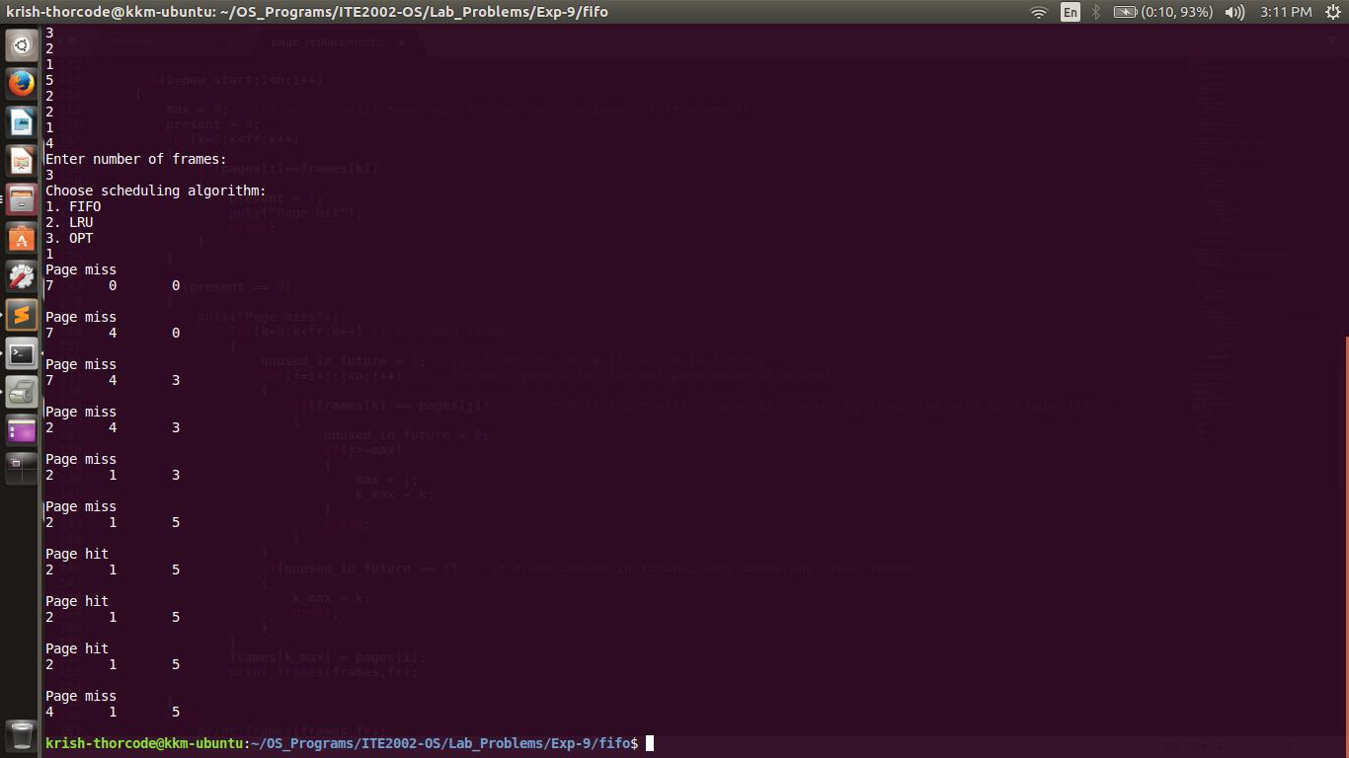

2. LRU

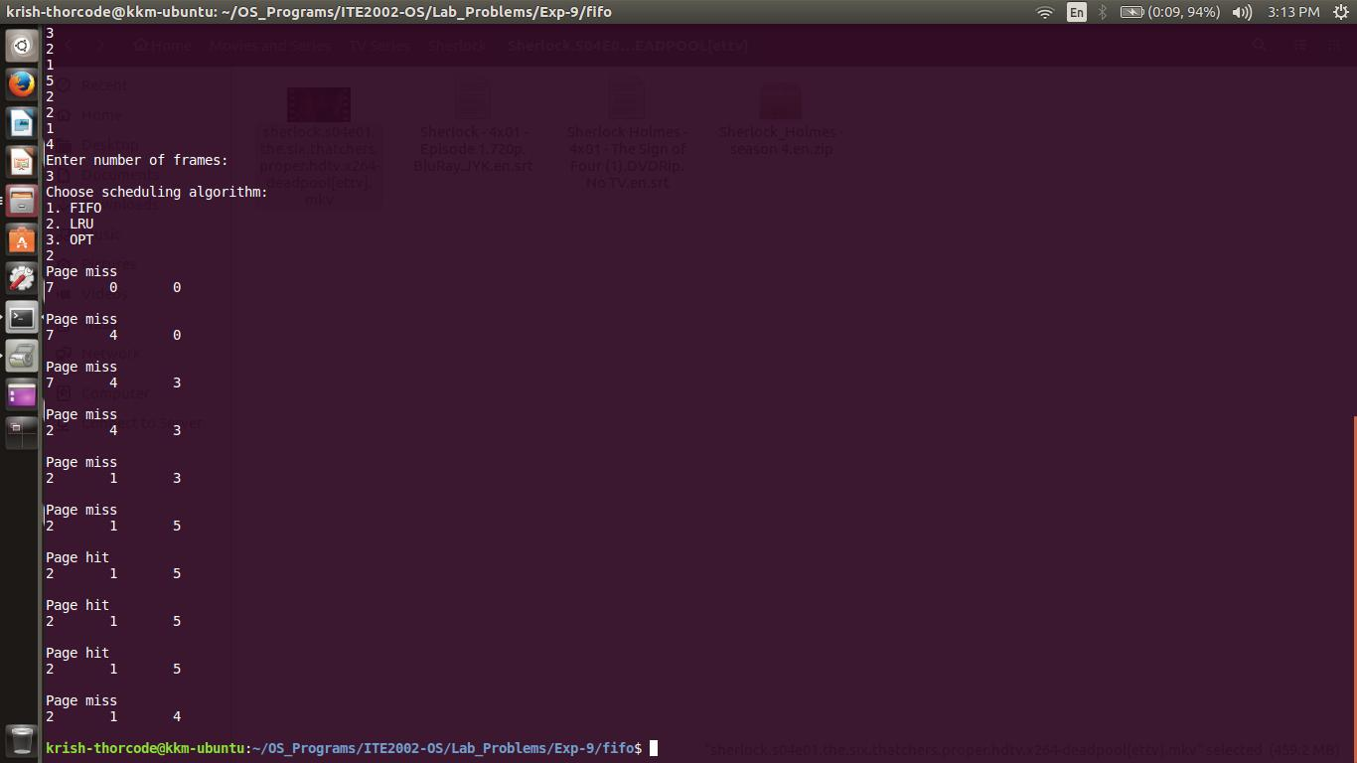

3. OPT
